Trapped in Time, Reality of Locked-in Syndrome: Basilar Artery Thrombosis

Ahmad Sayuti Jamal Abidi,Mohd Hisham Isa
Department of Emergency Medicine, Hospital Canselor Tuanku Muhriz, UKM KL Campus, Jalan Yaacob Latif, 56000 Cheras, Kuala Lumpur

Abstract

Locked-in syndrome is a rare neurological condition resulting from a basilar stroke, which causes severe damage to the brainstem. This condition leads to complete paralysis of all voluntary muscles in the body, except for eye movement and blinking. The individual is fully conscious and aware of their surroundings but unable to speak or move. A non-contrast CT brain may show hyperdense basilar signs.
Case report
We report a case of a 74-year-old male who initially presented with headache, vomiting, and a decrease in consciousness level upon arrival, with a GCS score of E4V1M4. The patient exhibited jerky movements in both lower limbs, which eventually progressed to tetraplegia. He demonstrated the ability to comply with instructions by using eye movements. He was intubated afterward to preserve his airway due to the risk of aspiration. The stroke protocol was initiated, and a non-contrasted CT brain showed hyperdense basilar signs that were highly suspecting of basilar artery thrombosis. CT angiography cerebral further confirmed the diagnosis of Locked-in Syndrome secondary to the Basilar Artery Thrombosis. He underwent thrombolysis and mechanical thrombectomy and was admitted to the intensive care unit and is currently already transferred to the general ward.
Discussion

Locked-in syndrome (LIS) is referred to as a neurological condition associated with infarction of the ventral. It is characterized by complete paralysis of all four limbs, weakness of the lower cranial nerves, and inability to speak. However, the patient can move the eyes up and down and remain cognizant. The primary cause is usually vascular, often resulting from either basilar artery obstruction or pontine hemorrhage leading to ischemia. This case highlighted findings of hyperdense basilar signs in the non-contrasted CT brain, which is highly suspicious of basilar artery thrombosis that was commonly missed.

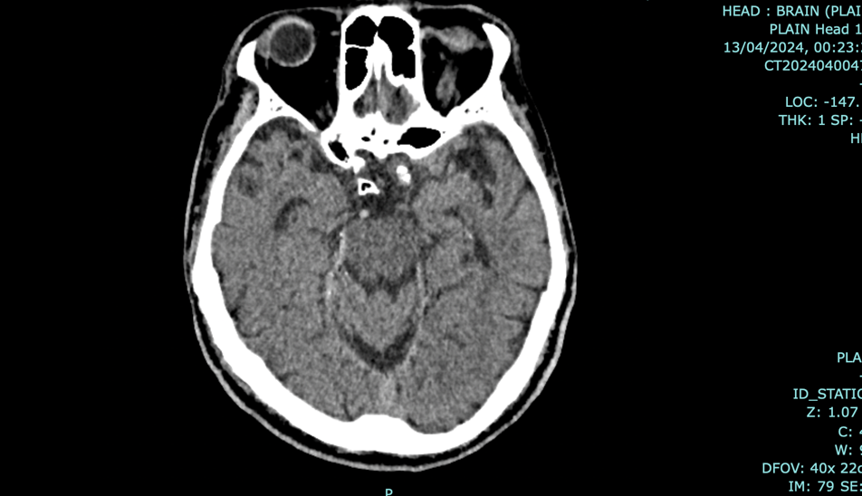

Figure 1: Non-contrast CT shows hyperdense basilar sign

Conclusion

Locked-in syndrome is a rare neurological disorder caused by an occlusion in the basilar artery. Early identification and medical intervention are crucial to prevent brainstem infarction and mortality. However, in about 65% of patients, a hyperdense basilar artery may be seen on non-contrast CT imaging, which confirms the diagnosis.

Keywords: Locked-in Syndrome, Basilar Artery Thrombosis, Hyperdense Basilar Sign

