**BORNEON SIMIAN’S SEIZURE**

**Atypical presentation of *Plasmodium knowlesi***

**CASE REPORT**

**INFECTIOUS DISEASE**

**CASE PRESENTATION**

A 61-year-old woman who lives in Sabah, Malaysia, with no comorbid presented to the emergency department due to unconsciousness. Further inquiry revealed her having fever for one day and routine activities of vegetable harvesting at the orchard. Upon examination, she was hypotensive with GCS of 3. Consequently, she was intubated for airway protection and required inotropic support. Blood tests indicated thrombocytopenia, renal and liver abnormalities while CT scan of brain revealed an acute pontine infarct with cerebral edema. Given her outdoor activities and blood parameter findings, a blood film for microscopy parasite testing was conducted, identifying *Plasmodium knowlesi* with a parasitemia of 35,000. This diagnosis was later confirmed through polymerase chain reaction. She was treated for cerebral malaria and treatment involved administering antimalarial artesunate and doxycycline. After two doses of artesunate, the parasitemia reduced to 480. Unfortunately, the patient succumbed to death due to multiorgan failure.

**DISCUSSION**

Malaria, a potentially life-threatening tropical infectious disease caused by Plasmodium parasites, spreads through bites of infected female Anopheles mosquitoes, maturing in the liver and proliferating. Severe malaria often involves organ dysfunction. In Malaysia, *Plasmodium knowlesi*, primarily Borneon simian parasite, is the main cause, with renal injury and acute liver failure as common severe manifestations. Unlike *Plasmodium falciparum* which is predominantly encountered in Sub-Saharan Africa, known for cerebral malaria, *Plasmodium knowlesi* rarely induces coma. The parasite sequestration causes vascular damage, leading to vascular leakage, brain hypoxia, and edema in severe cases. (Yusuf, 2017). This is the first reported cerebral malaria secondary to Plasmodium knowlesi in Asia. While there was a single probable case of cerebral malaria likely due to Plasmodium knowlesi (Cox, 2010) but it did not meet WHO standards for cerebral malaria (WHO, 2000)

**TAKE HOME MESSAGES:**

Even though coma is an uncommon sign of Plasmodium knowlesi infection, neurological symptoms associated with prior jungle activity call for additional parasitological testing, particularly in areas where the parasite is extensively endemic.

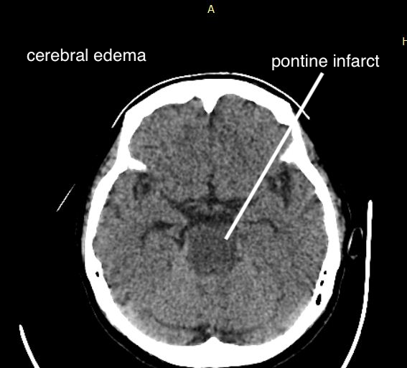

**REFERENCES**

Song, X., Wei, W., Cheng, W., Zhu, H., Wang, W., Dong, H., & Li, J. (2022). Cerebral malaria induced by plasmodium falciparum: clinical features, pathogenesis, diagnosis, and treatment. Frontiers in Cellular and Infection Microbiology, 12. https://doi.org/10.3389/fcimb.2022.939532

Cox-Singh, J., Hiu, J., Lucas, S. B., Divis, P. C., Zulkarnaen, M., Chandran, P., Wong, K. T., Adem, P., Zaki, S. R., Singh, B., & Krishna, S. (2010). Severe malaria - a case of fatal Plasmodium knowlesi infection with post-mortem findings: a case report. Malaria Journal, 9(1). https://doi.org/10.1186/1475-2875-9-10

Yusuf FH, Hafiz MY, Shoaib M, Ahmed SA. Cerebral malaria: insight into pathogenesis, complications and molecular biomarkers. Infect Drug Resist. 2017 Feb 2;10:57-59. doi: 10.2147/IDR.S125436. PMID: 28203097; PMCID: PMC5298296.

Severe falciparum malaria. World Health Organization, Communicable Diseases Cluster. (2000). *Transactions of the Royal Society of Tropical Medicine and Hygiene*, *94 Suppl 1*, S1–S90.