**ABSTRACT**

Title: Primary adrenal insufficiency: the rare encounter

Main authors: Siti Murni Fitri bin Mohd Shukor

Co-authors: Hashim Embong

**Introduction**

Primary adrenal insufficiency (PAI), also known as Addison's disease, is a condition characterised by the inadequate production of adrenal hormones due to dysfunction or destruction of the adrenal cortex. The causes of PAI are autoimmune adrenalitis, tuberculosis or fungal infections, and congenital adrenal hyperplasia. Although it is rare, PAI could also be manifested as a complication of antiphospholipid syndrome (APS).

**Case description**

We report a case of a 37-year-old Malay gentleman with no history of illness who was involved in a motor vehicle accident and sustained a left middle phalanx 5th finger chip fracture done K-wire insertion in a private hospital and was discharged well. Since then, he had poor appetite and nausea. His vital signs showed hypotension, tachycardic, and afebrile with normal oxygen saturation. Despite adequate hydration and no excessive losses from the body, his blood pressure remains borderline low, with hyponatraemia (118mmol/L), hyperkalaemia (5.7mmol/L) and random blood glucose of 5.1mmol/L. The morning serum cortisol level was low (91nmol/L). The CECT abdomen revealed a bilateral adrenal haemorrhage. He also developed left-hand gangrene, likely secondary to newly diagnosed anti-phospholipid syndrome. He had undergone left distal 3rd trans-radial amputation and was discharged with oral corticosteroids.

Image 1: CECT abdomen bilateral adrenal haemorrhage

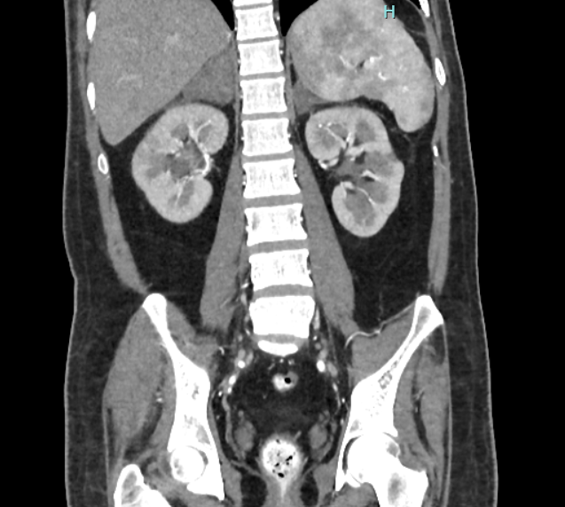

The yellow arrow shows enlarged bilateral adrenal glands with mixed hypo- to hyperdense content, likely representing bilateral adrenal haemorrhages.

**Discussion**

Bilateral adrenal haemorrhage developed most probably due to anti-phospholipid syndrome (APS). A common hypothesis is that adrenal vein thrombosis could occur when the transition from the arterial to the capillary system is so abrupt that it constitutes a “vascular dam,” which causes the accumulation and stasis of blood in the hypercoagulable state of primary APS. Only 0.4% of patients with APS develop PAI over a follow-up period of 5 years. When catastrophic APS occurs, adrenal insufficiency frequency rises to 10–26%. The mortality rate of patients with APS complicated by adrenal insufficiency is 3.81%, a relatively high percentage given their young age.

**Conclusions**

PAI can be the first manifestation or may develop later during APS. Due to its insidious onset and non-specific symptoms, physicians may overlook PAI, which leads to delayed diagnosis and treatment.

**Keywords**

Primary adrenal insufficiency, Addison’s disease, anti-phospholipid syndrome